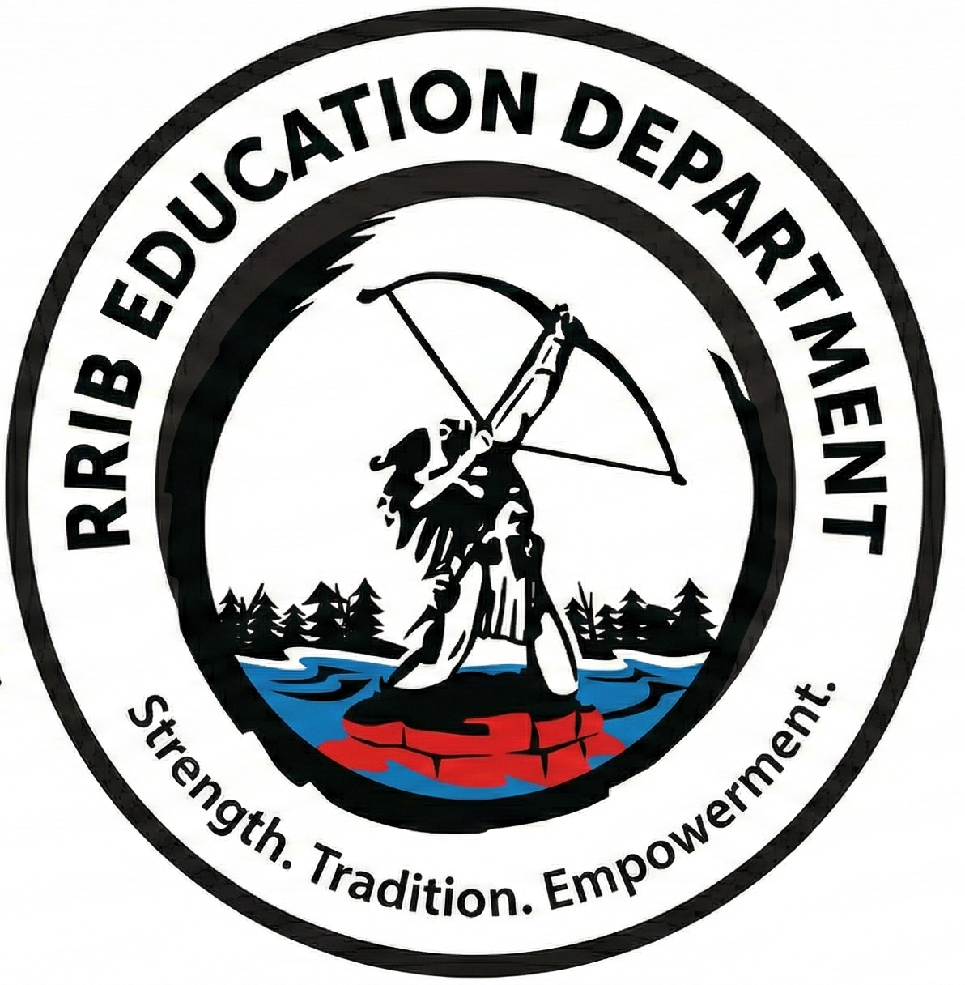
Red Rock Indian Band - Employment Opportunity

Indigenous Student Support Worker
(2 Full-Time – 10-Month Positions)
- One (1) position – George O’Neill Public School, Nipigon ON
- One (1) position – St. Edward’s Catholic School, Nipigon ON

About Red Rock Indian Band Education
Red Rock Indian Band (RRIB) Education Department delivers a continuum of programs and services that support students and families across their educational journey.
Our approach reflects a shared responsibility model between community, families, schools, and partner organizations, with a strong emphasis on student well-being, cultural identity, attendance, and overall student success.

POSITION SUMMARY
Red Rock Indian Band is seeking two compassionate, community-minded, and student-focused Indigenous Student Support Workers to join our Education Department.
The successful candidates will work collaboratively with school staff, RRIB Education staff, families, and community partners to support the academic, social, emotional, and cultural well-being of RRIB students.
These positions play a key role in strengthening school engagement, attendance, and student success, while promoting Indigenous identity, belonging, and pride within the school environment.
The successful candidates will report to the Education Director and work within a shared-responsibility model between RRIB and partner schools.

KEY RESPONSIBILITIES

Student Support
- Build trusting relationships with RRIB students through mentorship, encouragement, and advocacy
- Provide individual and small-group support (academic, social, emotional)
- Assist students experiencing barriers to attendance, engagement, and learning
- Support students during key educational transitions

Family and Community Engagement
• Act as a liaison between home, school, and RRIB Education
• Support communication with families regarding student success
• Assist families in accessing community services and supports
• Participate in student support meetings and collaborative planning

Attendance and Student Engagement
• Support RRIB attendance initiatives
• Develop strategies that encourage consistent school attendance
• Assist with interventions that strengthen student belonging and engagement
• Participate in home visits and family meetings, where appropriate

Cultural Programming
• Support cultural learning opportunities within the school
• Assist with language, cultural, and land-based programming
• Work alongside Elders, Knowledge Keepers, and community members
• Promote Indigenous identity, culture, and belonging

Educational Programming Support
• Support literacy, numeracy, and student success initiatives
• Assist with reading intervention, speech and language, and small-group instruction
• Contribute to transition programming and before/after school supports
• Support community-based educational activities and events

Team Collaboration
• Work collaboratively with educators, administrators, RRIB staff, and partners
• Participate in student support meetings and case conferences
• Maintain confidentiality and professional standards
• Demonstrate flexibility, initiative, and problem-solving

QUALIFICATIONS
Diploma, degree, or equivalent experience in a related field
Experience working with children and youth
Strong interpersonal and communication skills
Ability to work independently and in a team
Knowledge of community resources

CONDITIONS OF EMPLOYMENT
A current Vulnerable Sector Check and valid Ontario driver’s licence required.

COMPENSATION
Competitive salary and benefits package commensurate with qualifications and experience.

APPLICATION PROCESS
Submit cover letter, resume, and three references to jobs@rrib.ca
Application Deadline: July 23, 2026 @ 4:00 PM

Recruitment & First Nations Preference
Red Rock Indian Band values Indigenous knowledge, lived experience, and community connection and supports the recruitment, training, and professional development of its members. The Red Rock Indian Band shall give preference to Aboriginal people who possess the requisite skill sets and experience. RRIB encourages applications from all qualified candidates and remains committed to an objective, criteria-based hiring process.

